
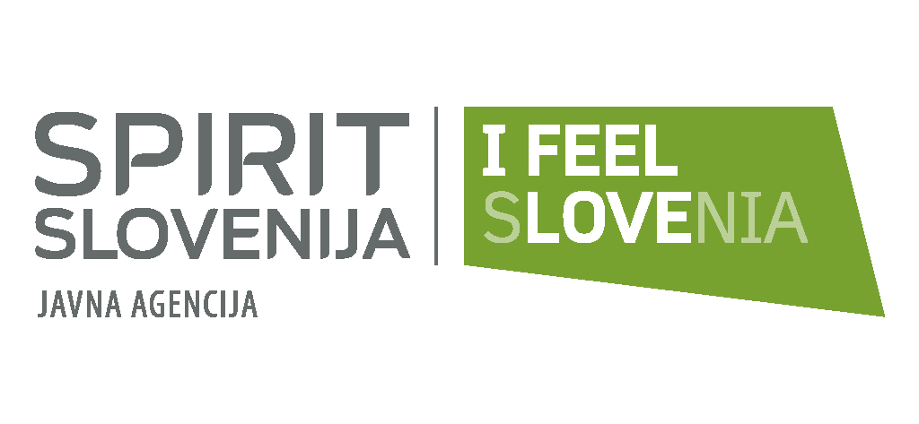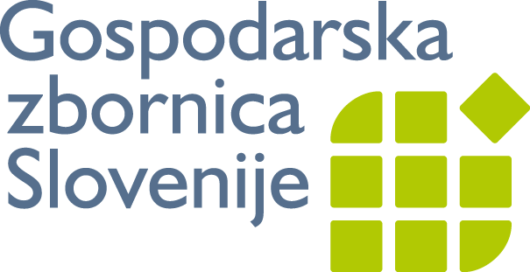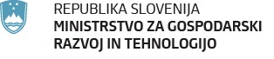

Vrniti najkasneje do
18. oktobra 2013 na:
E: marko.jare@gzs.si
ali
F: 01/58 98 100

Slovenian Business Delegation to Poland, Krakow 21 -22 November 2013

Company Profile

- Company Profile - Description of the company

(All fields are mandatory)
Company: |  | City: |  |  | Country:
Street: |  |  |  |  | Postal Code:
Webpage: |  | Contact person:
Position in the company: |  | Telephone: |  |  | Fax
General e-mail address: |  |  | E-mail contact person:
Year established:
Turnover in million Euro: |  |  |  | Number of employees in the enterprise:
Activity Code (NACE Codes if available):
Contact Languages: |  | English | Others:

Company's current products/activities, particularly with regard to the co-operation request (main products, services, core activities):

Certification/Quality standard:
None ISO9000 ECOAUDIT Other, specify:

Already engaged in Trans-National Co-operation:
Yes No

Percentage of Trans-National Activity (defined as approximate of turnover): .........%

B. Co-operation Proposal - Description of the co-operation sought

Type of co-operation:

Commercial co-operation
Trade Intermediary (agent, representative, distributor) | offered requested
Franchise | offered requested
Transport/Logistic | offered requested
Joint Venture | offered requested
Merger or exchange of shares | offered requested
Sale / Acquisition of a complete company or a part of it | offered requested
Reciprocal Production | offered requested
Subcontracting / Outsourcing activities | offered requested

- The full description must be detailed and reflect all elements of the profile, each type of co-operation selected must be explained in detail .You can add any other additional information that you find interesting. Describe here the advantage(s) offered by your company and why it should be selected by the potential business partners.
Full Description (specification of co-operation
request/offer)

Description of the main advantages the company
could offer to a potential partner

- Describe the required characteristics of the potential partner

Type of partners: | Company Other (please specify):

Field of activities of the potential partner: | Manufacturing  Services  Trade (buying/selling)

Number of employees of the potential partner: | 1-9  50-249 | 10-49  More than 250

Trans-National Co-operation experiences of the potential partner: | No preference Preferred Required
Expected input/Characteristics of the partner: (Description of what is expected from the co-operation partner)

Date:
................................
proper signature

